TODAY’S DATE

To International Student Services at California Baptist University,

This letter is to verify that STUDENT’S FULL NAME has been offered a PAID OR UNPAID position as a POSITION TITLE at our organization, ORGANIZATION NAME. STUDENT’S NAME will be WOKRING/VOLUNTEERING as part of an academic requirement related to HIS/HER studies at California Baptist University. Details of HIS/HER position are listed below:
Start Date:
End Date:
Full-time or part-time:
Address of site:

If you have any questions, please contact me at the information listed below.

SIGNATURE

PRINTED NAME
PHONE NUMBER
EMAIL ADDRESS


August 20, 2022

To International Student Services at California Baptist University,
SAMPLE

This letter is to verify that Nathan Landry has been offered an unpaid position as a Lead Intern at our organization, The International Center. Nathan will be volunteering as part of an academic requirement related to his studies at California Baptist University. Details of his position are listed below:
Start Date: September 1, 2022
End Date: December 1, 2022
Full-time or part-time: Part-time
Address of site: 8432 Magnolia Avenue, Riverside, CA, 92504

If you have any questions, please contact me at the information listed below.
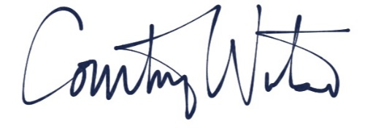

Courtney Watson
951-343-4690
cwatson@calbaptist.edu

